Problem statement:
Develop a web application using SpringBoot or .NET
The project is Restaurant Management system using Spring JPA and Angular.
It is of group project of 2 in which I majorly contributed towards Backend.
In this project we will mainly focus of product management and bill management.
There are two types of roles exists in our project admin and user.
User:
User has to create an account first in order to login.
After successful login all the available products and their categories were displayed.
He can also search products in the search bar.
User add the products inside the cart and bill receipt will be generated and downloaded.
Admin:
After successful login of admin he will be redirected to the same dashboard as user. But admin will have some extra options.
He have manage category option. Inside it he can add categories, delete categories. If a category got deleted all the corresponding products inside it gets deleted.
He have manage product option. Inside it he can add products, delete products of a particular category.
And other options such as searching products, adding them inside and making a bill is same as user.

Highlights of the project:
1. Authentication using JWT tokenization.
3. Bill receipt download.
4. Visually appealing frontend :
a)Search Option:
Users can search products.
b)client-side validations:
i.e during signup or login when we write wrong details inside the form immediately it gives inline error
notifications like password and confirm password should match, wrong email format.
Submit button will work only after entering all the required details in the form.

1. JWT Authentication:
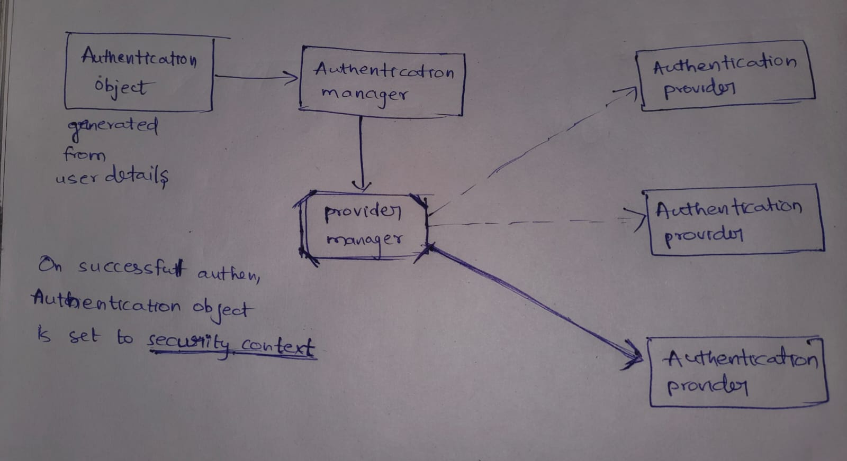
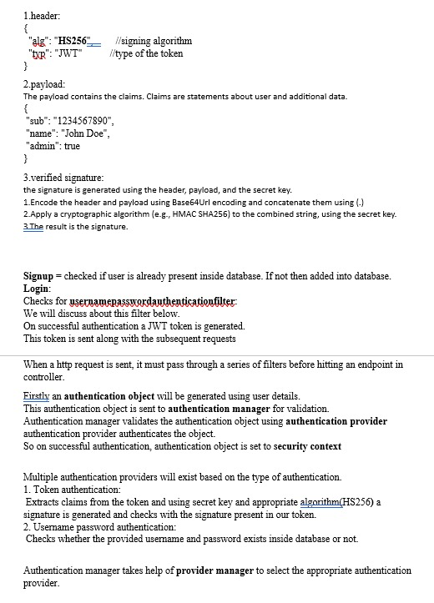

Why do I prefer JWT over session cookies:
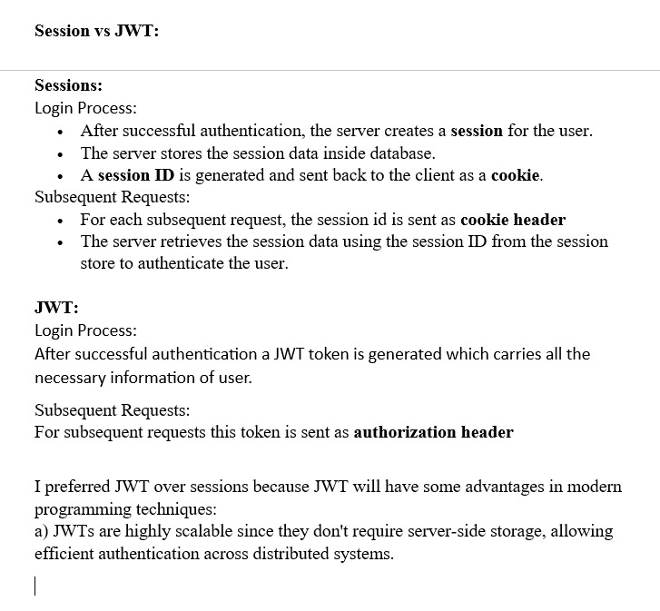

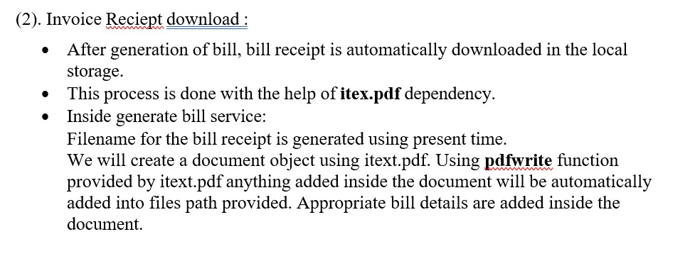

Why do I prefer JPA over JDBC because?
JPA reduces the overhead of writing SQL queries upto some extent and the company also mainly uses JPA.

JPA:
JAVA objects are mapped to backend tables using @entity annotation.
So that any operation done on the JAVA objects inside the services will get reflected in backend tables
Ex:
ProductRepository.save()
ProductRepository.find()
ProductRepository.findById()
ProductRepository.deleyeById()

JDBC:
Interaction with database is done using SQL
SQL queries were run using JDBCTemplate

4. Client side validations:
When we enter any input in signup form or login form in wrong format then immediately an inline error message will be displayed like wrong email format or password and confirm password should match.
When can able to click submit button only after entering all the details inside the form.

This is done by using formBuilder and Validators classes from @angular/forms package.

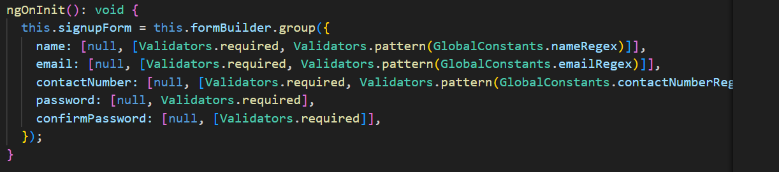
Here while creating form using formBuilder we add validators to each attribute.
Each validator will validate the entered attribute based on REGEX provided.
validator.required = should not be left empty
validator.pattern(regex) = should match with the regex.

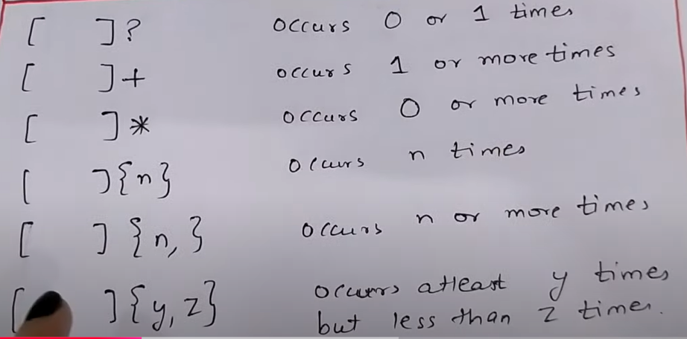
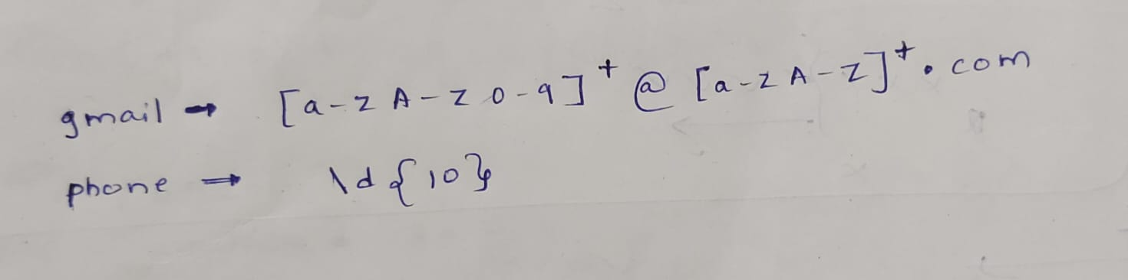

5. Search option:
mat-form-field is used for taking input in search bar
searching is done by MatTableDataSource.filter( ) function
Difficulties:
Implementing JWT authentication is bit difficult
Tried to implement password management using Bcrypt(hashing) but failed to understand the concept of Bcrypt.
other than that there are no much difficulties but the other guy faced many difficulties in choosing appropriate angular material library that fits our project.

Improvements:
Project might be made to take online food deliveries like Zomato.

Userservice:
signup :
JSON data is converted as request map using @RequestBody annotation in controller
inside the service using email name from the request map we make sure user don't exist in database.
If not exists then we create a User object from the request map and then we save it inside database.
By default his role is marked as user

login:
Firstly request will pass through username password authentication filter.
After successful authentication a JWT token is generated.
Redirected to user dashboard

Categoryservice:
add new category:
Used in manage category option of admin.
First checks whether admin or not then adds a new category inside database.

delete category:
Used in manage category option of admin.
First checks whether admin or not then adds a deletes category inside database.
Because of cascading corresponding products also deleted.

get all category1:
In manage category option of admin, first checks whether admin or not and then, it shows all categories
get all category2:
In making bill by either admin or user, it shows the categories that contains products.

Product Service: (category attribute is a foreign key)
Add new product:
same as above

Delete product:
same as above

get product1:
In manage product option of admin, first checks whether admin or not and then, it shows all products
get product2:
In making bill by either admin or user, it shows the product that present in particular category..

Bill: (contains user email, product details, amount) (userid is a foreign key)
Generate report: When user clicks the submit button.
Bill receipt is downloaded and inserted to database

Bean vs Component:

The primary use of either bean or component is to support dependency injection.
Bean : Dependency injection is completely done by user by manually creating methods which will
return the desired objects that have to be injected.
All methods are created inside a configuration. Each method returns an object
(open spring_beans code and see gaming example)
Component : Only thing to do is add annotation @Component at the class that have to be
injected at another place so that spring itself creates the object for us and this is
known as autowiring.

Version of Angular : angular16

Spring vs Spring boot?
Starter pack
Accumulators

